<https://www.youtube.com/watch?v=GWKZjmjdSGU&t=181s>

<https://www.youtube.com/watch?v=m0AnxQ5w_-s>

<https://github.com/narottamgoyal/Kafka.Masstransit.WebApi>

<https://www.youtube.com/watch?v=V0lLs05yh4s> --- AWS Data Streaming services. Apache kafka, AWS KDS, AWS MSK and Confluent Kafka

<https://www.youtube.com/watch?v=y4wowEQd4Os> -- Create a Kafka Cluster using AWS MSK And Stream data.

<https://www.youtube.com/watch?v=f52IOtTqcP8> --- Connect to AWS EC2 instance via ssh from windows

<https://www.youtube.com/watch?v=ARqyWaZqn68> --- Dotnet Core to Apache kafka

<https://www.youtube.com/watch?v=HtU9pb18g5Q> --- Apache Kafka on AWS

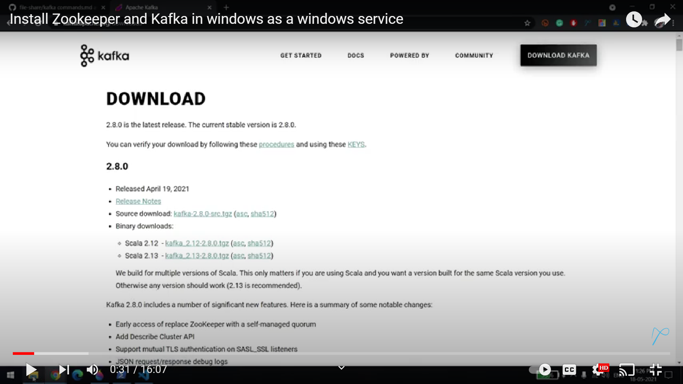

Kafka Config folder

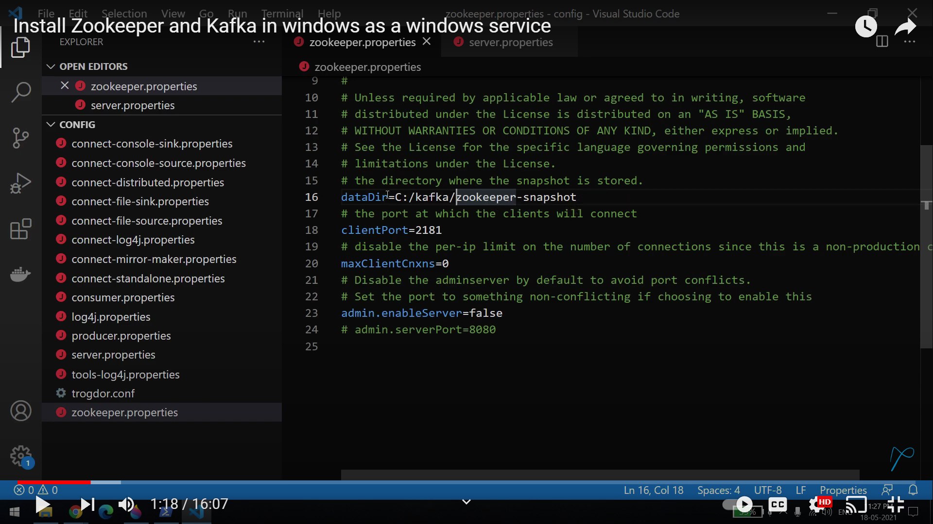

Server path

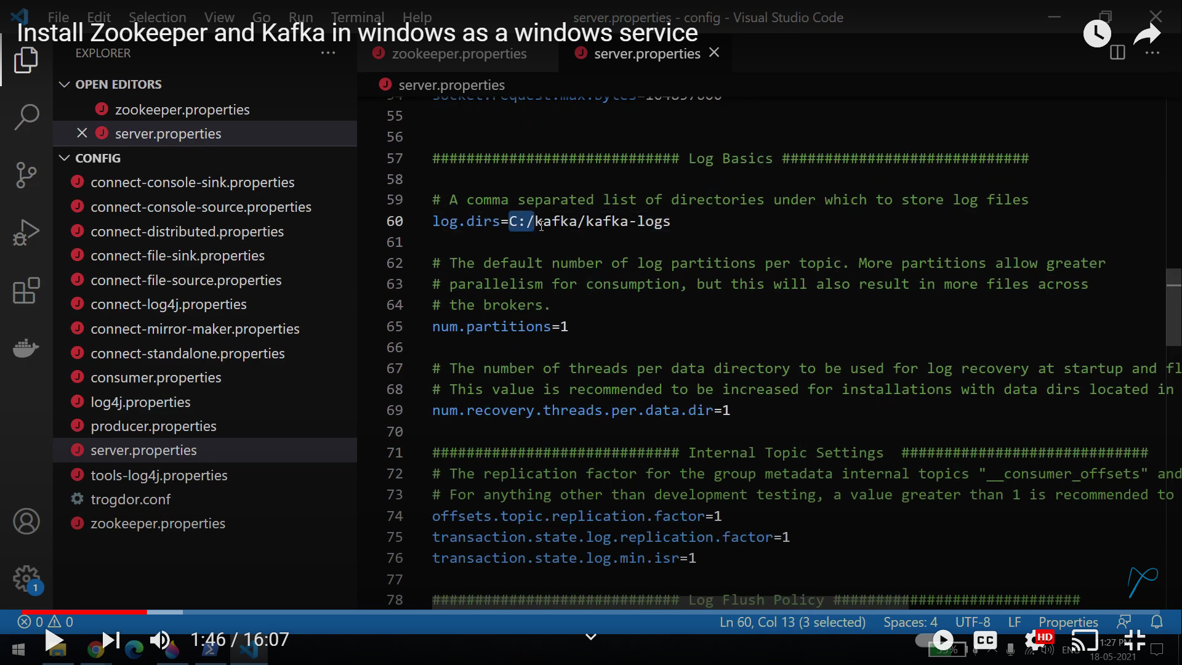

Open command prompt

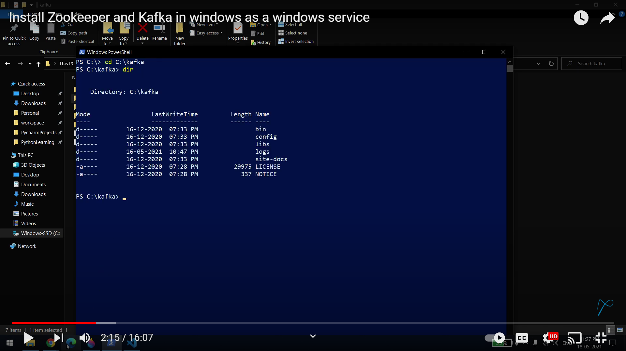

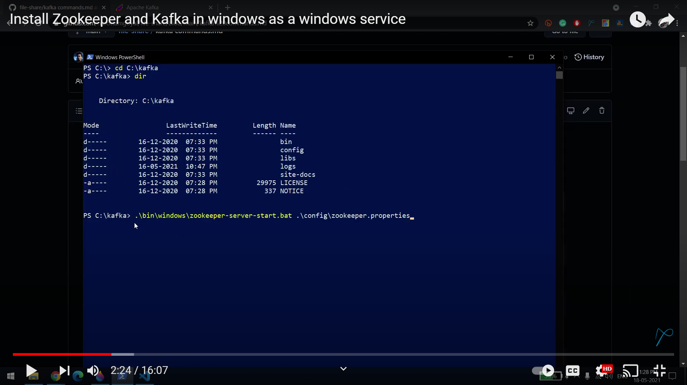

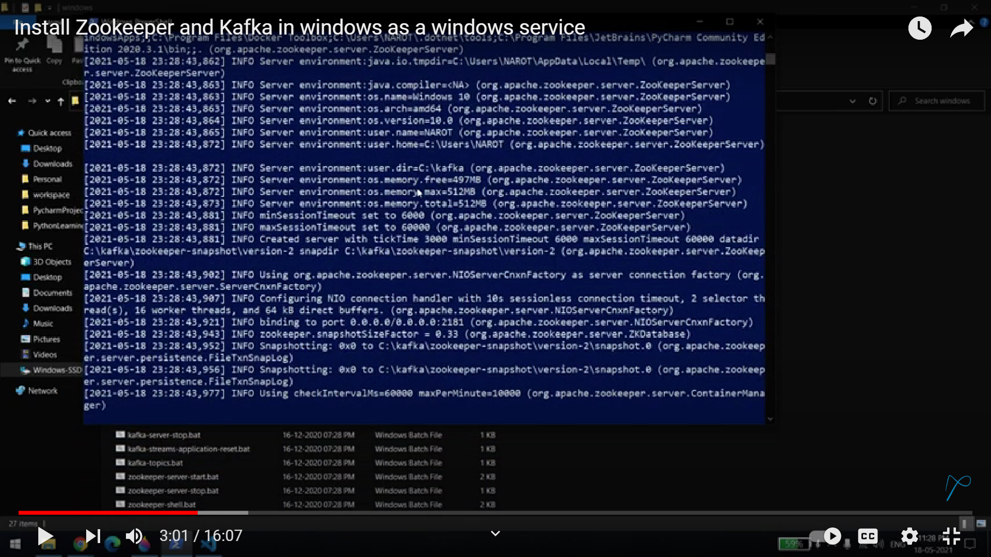

Open second window for kafka

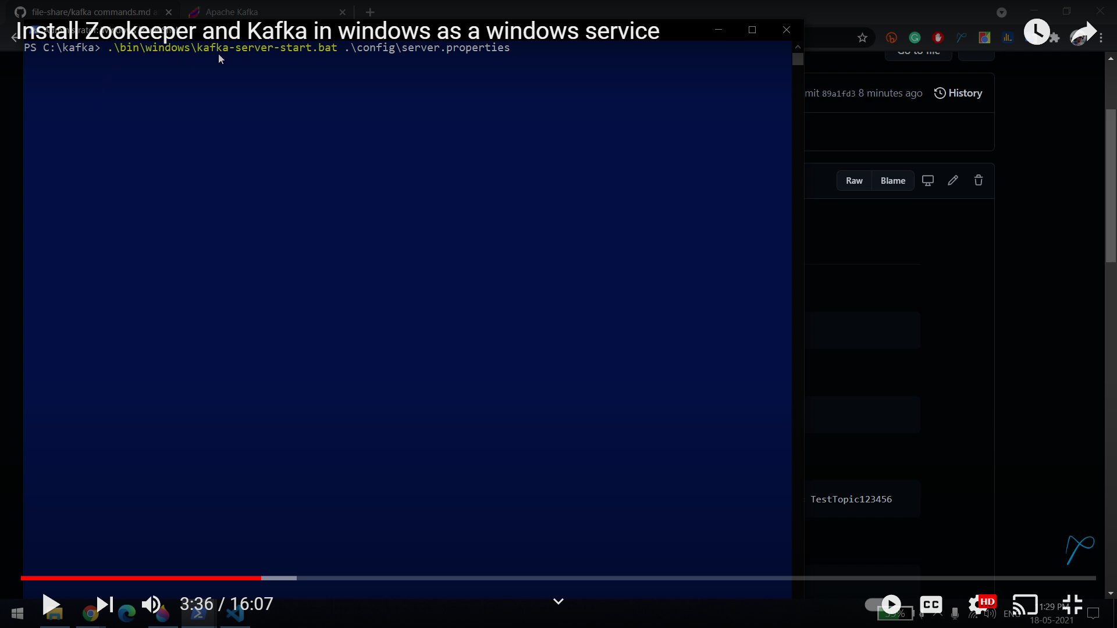

Open third window

To create topic and list the topic

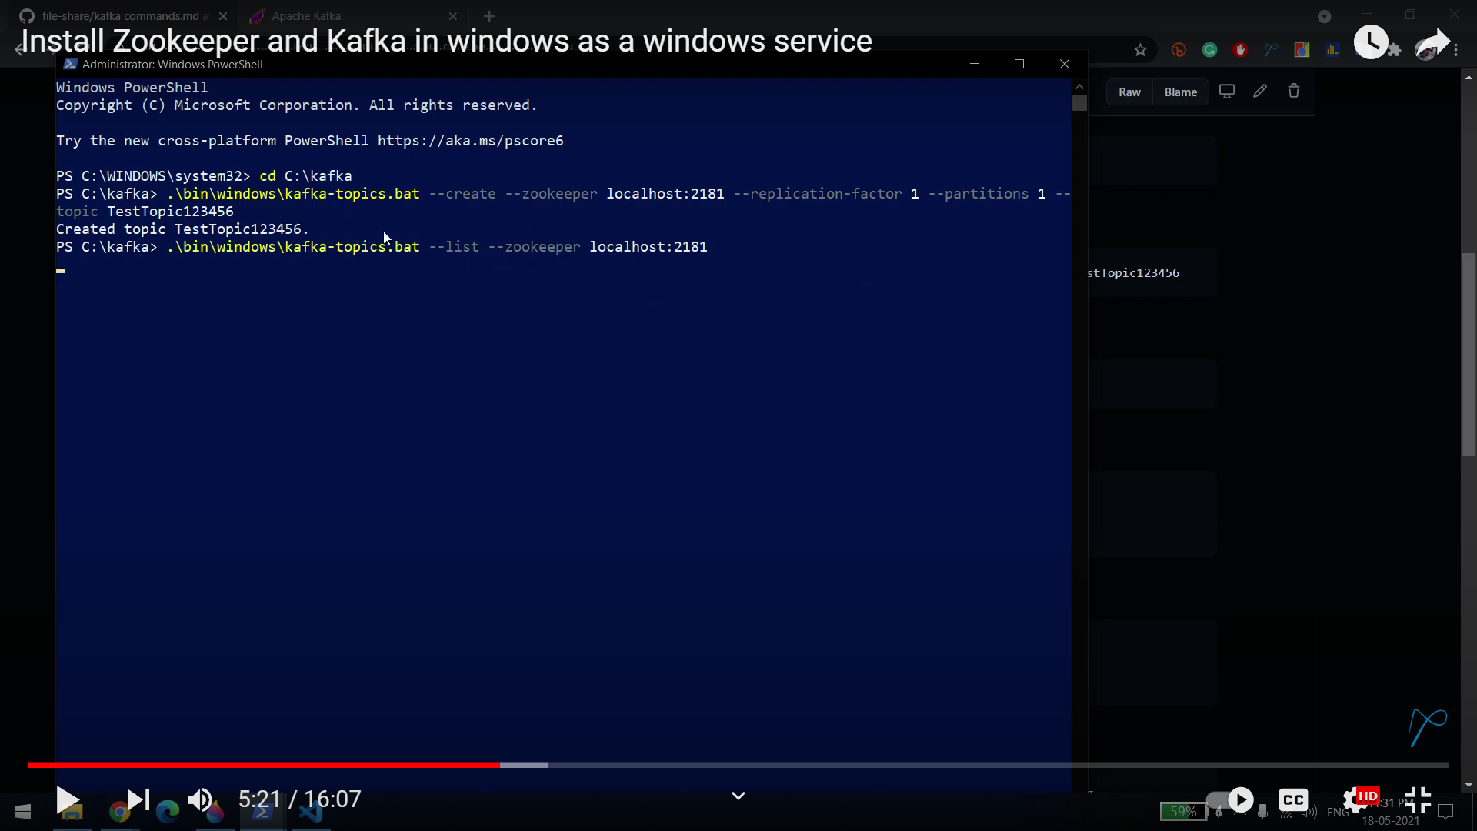

Create fourth window for producer

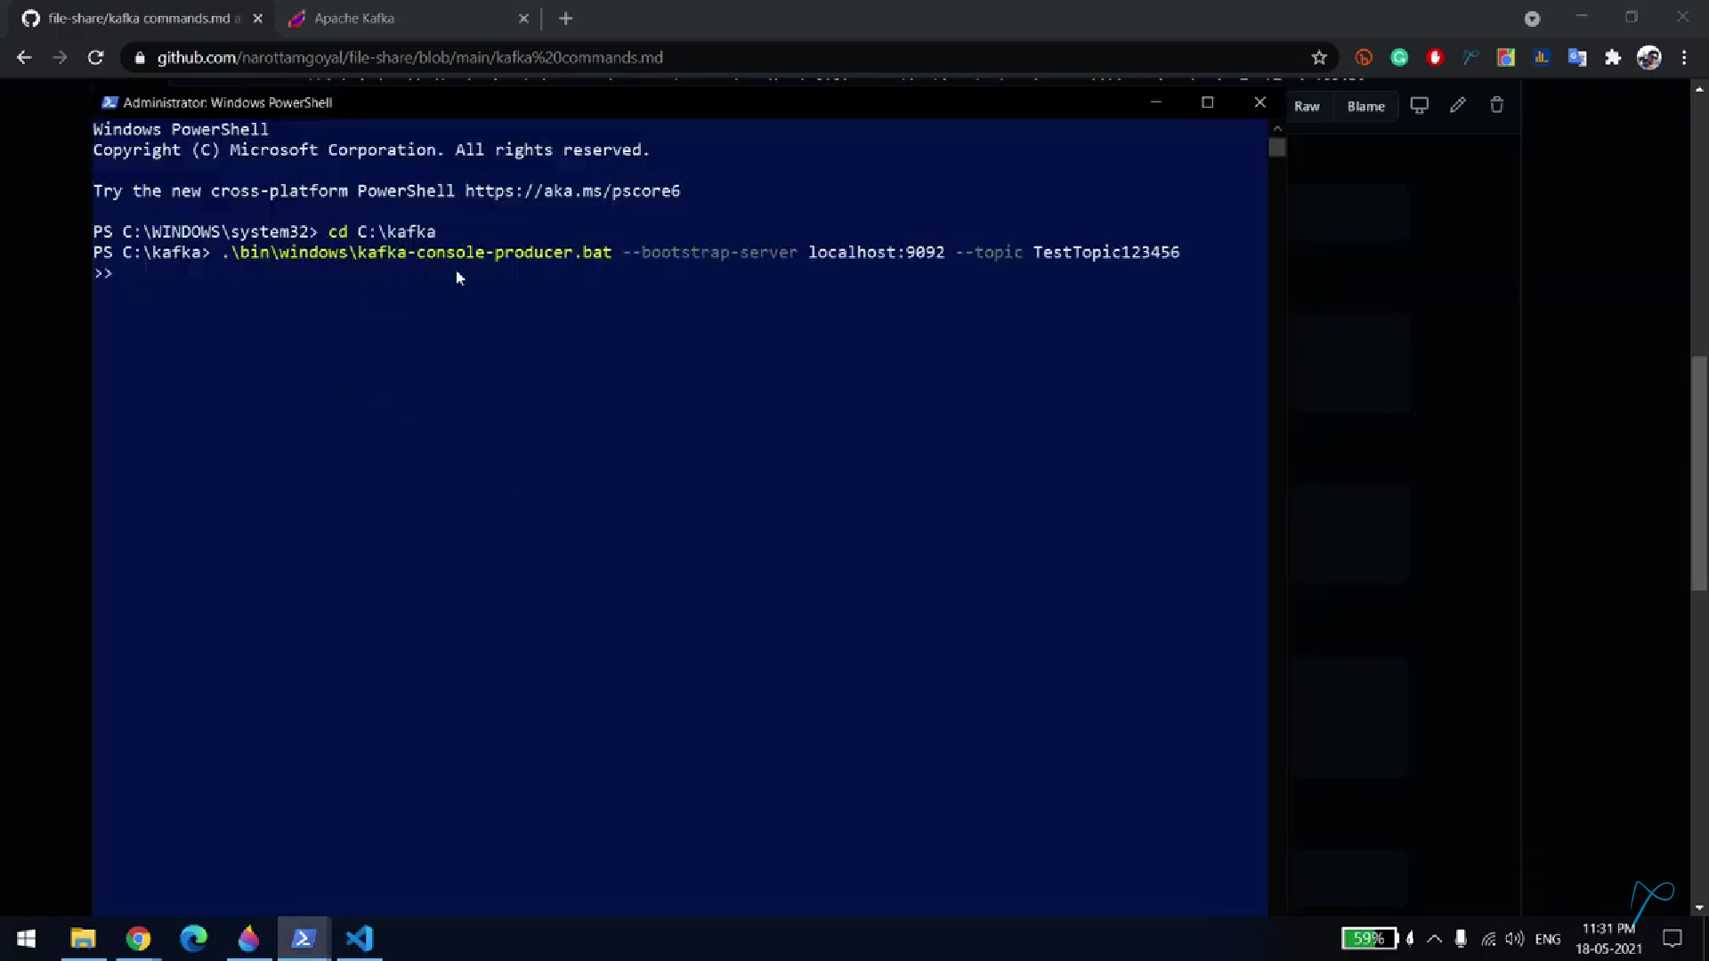

Fifth window for Consumer

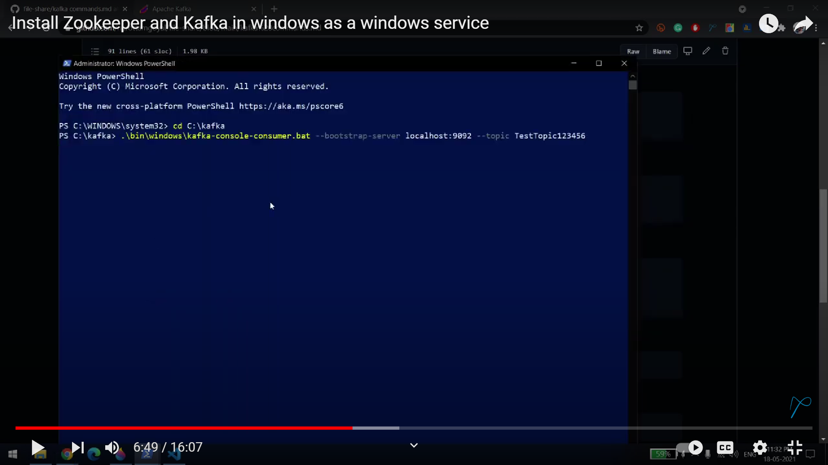

Receive messages frombegining

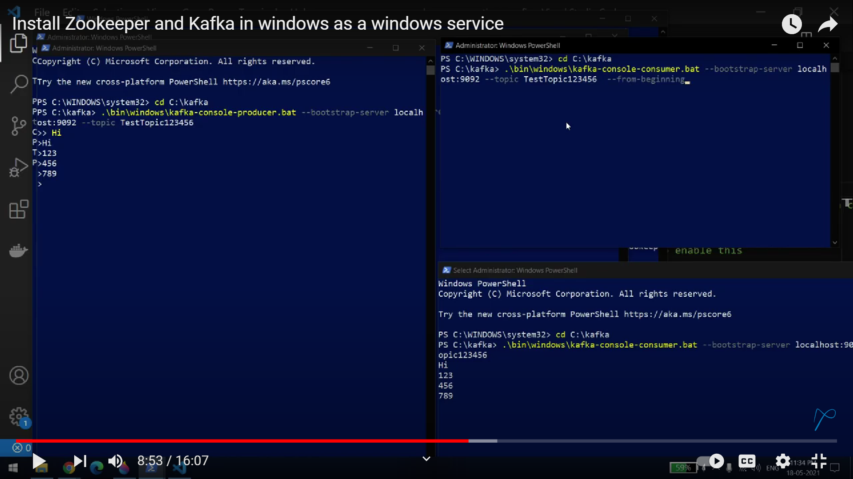

Nssm tool to host them in server

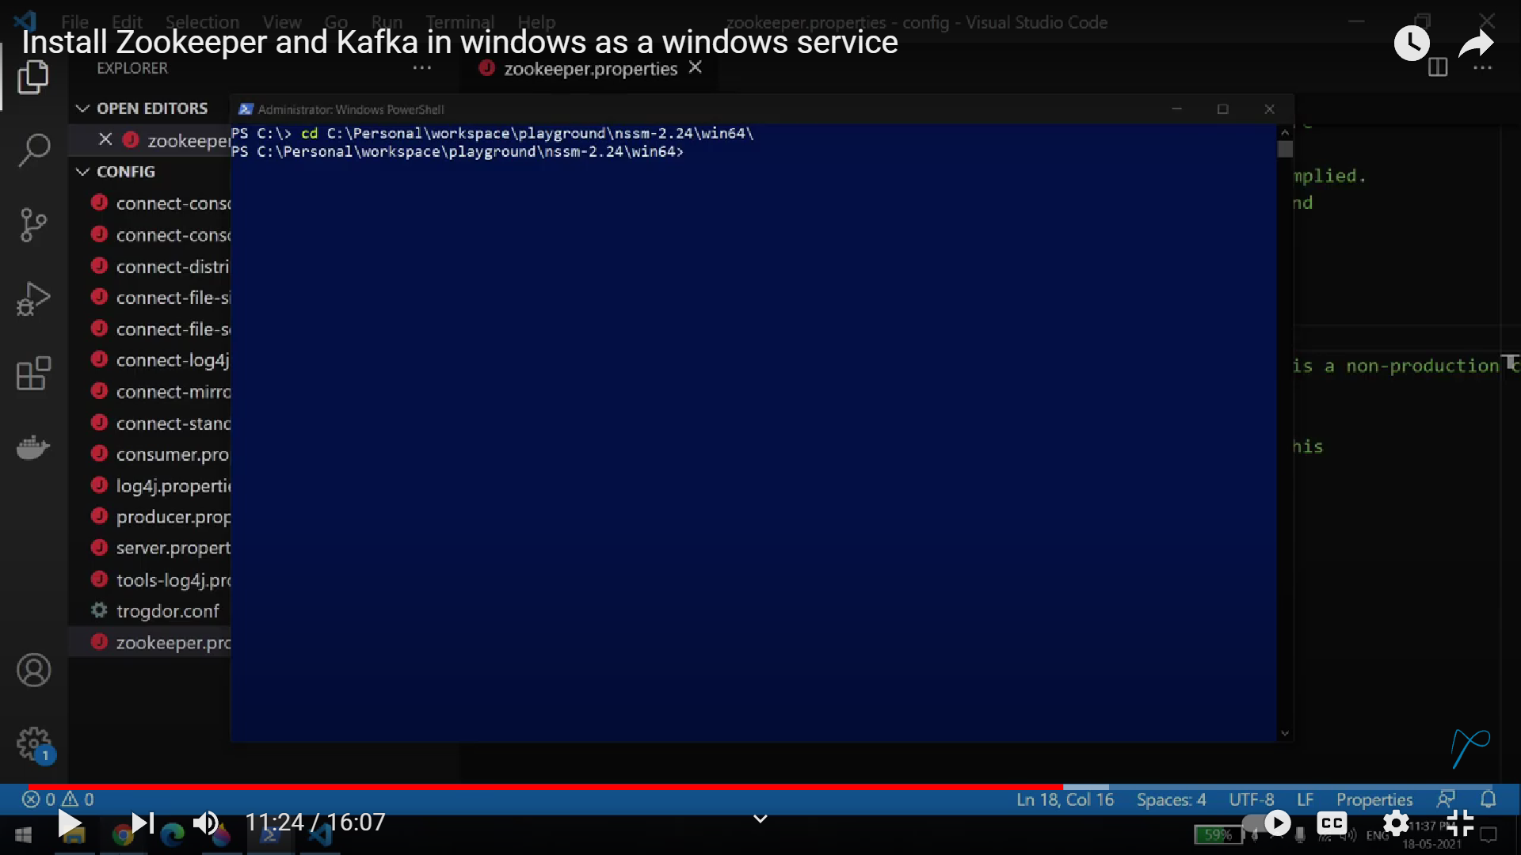

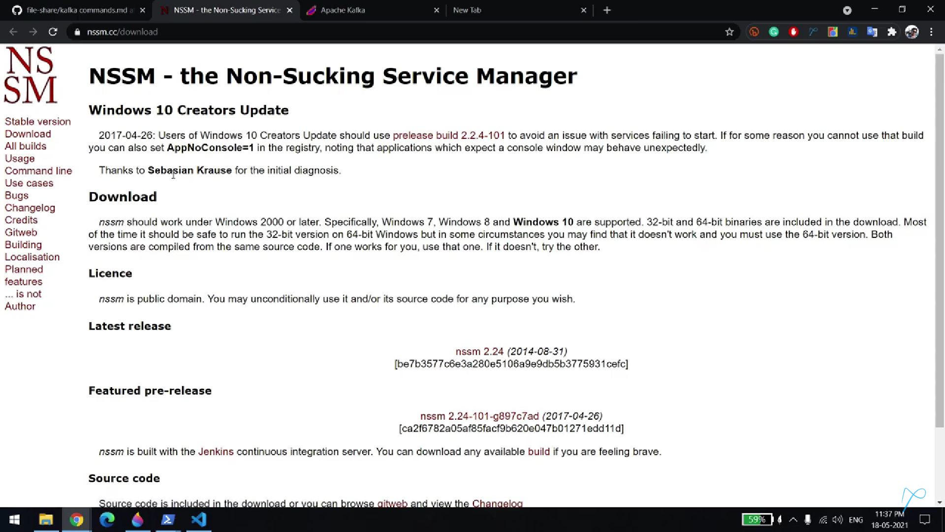

Open the same zookeeper command in NSSM

Kafaka and zookeeper services are installed in NSSM, but stopped

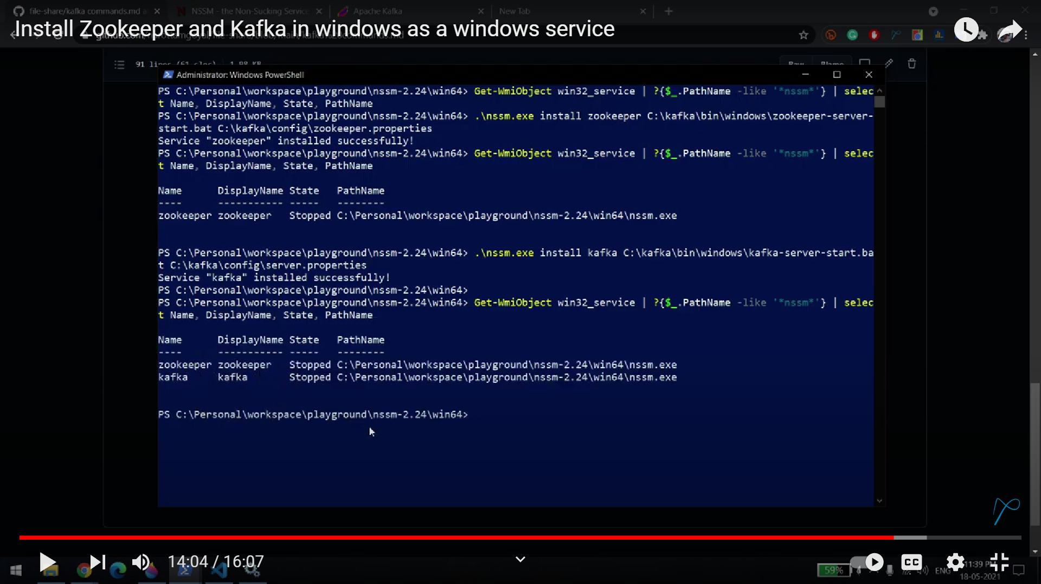

Now started both zookeeper and kafka services

